Information Engineering Technology
Project Name: AI Chatbot for Student Queries
Subject: Software Engineering
Semester: 4th
SUBMITTED TO:
Ma, am Javeria Saeed
SUBMITTED BY:
Sr. | Name | Roll No.
1 | Arif Hussain | SU91-BIETM-F24-013
2 | Ameer Hamza | SU91-BIETM-F24-018
3 | Asim Shahzad | SU91-BIETM-F24-020
4 | Ahmad Riaz | SU91-BIETM-F24-023

- Introduction
The Smart Campus System is an AI-based chatbot designed to help students by providing quick and automatic answers to their academic and campus-related queries. The system allows students to easily access information about attendance, exams, fee details, class schedules, and university announcements at any time. This project improves communication between students and university administration, reduces manual workload on staff, and provides a smarter and more efficient support system for educational institutions.
- Problem Statement
Students often face problems for getting information quickly from university staff. They have to wait for replies about exams, attendance, fees, and class schedules. This increases workload for administration staff and wastes student time.
The AI chatbot system will solve this problem by giving quick and automatic replies.
- Project Objectives
- Give quick answers to student questions
- Reduce workload on university staff
- Improve communication between students and university
- Provide support 24 hours a day
4. Project Requirements
Functional Requirements
- AI chatbot for answering student questions
- Show timetable information
- Show attendance information
- Show exam schedules
- Show fee information
- Send notifications and announcements
- Allow admin to update information
Non-Functional Requirements
- Fast system response
- Easy to use interface
- Secure system
- Reliable performance
5. Technologies Used
- Python
- AI Chatbot Integration
- MySQL Database
- Visual Studio Code
6. Feasibility Study
A feasibility study is performed to check whether the project is practical, achievable, and beneficial for the university.
Technical Feasibility
The project is technically feasible because all required technologies, software tools, and development resources are available. The chatbot can be developed using Python, AI integration tools, MySQL database, and Visual Studio Code. These technologies are easy to access and suitable for chatbot development.
Operational Feasibility
The system is operationally feasible because students and university staff can easily use it. The chatbot improves communication, saves time, and reduces the workload on administration staff by providing automatic responses to common student questions.
Economic Feasibility
The project is economically feasible because the development cost is low. Most tools and software used in the project are free or open source. The system also helps save time and resources by reducing manual work.
Schedule Feasibility
The project is schedule feasible because it can be completed within the academic semester. The project requirements, development process, and testing can be managed within the given time period.

Gantt Chart:

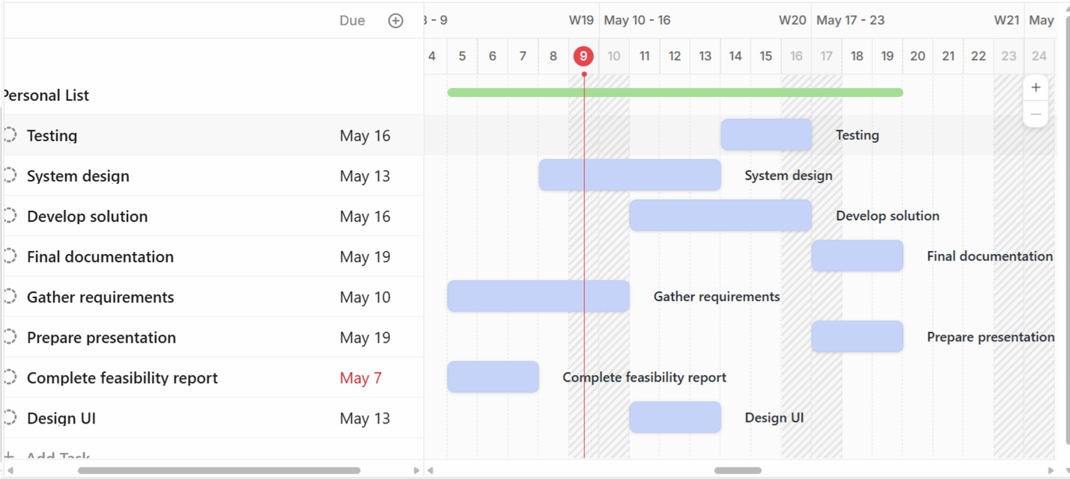
7. Scope of the Project
- Answer student questions
- Provide academic information
- Send reminders and notifications
- Improve student support services

Software Requirements Specification (SRS)
Introduction
The Smart Campus System is an AI-based chatbot system developed to help students by answering academic and campus-related queries automatically. The system provides quick access to important information such as attendance, exams, fees, class schedules, and university announcements.
Purpose
The purpose of this system is to improve communication between students and university administration by providing automatic and quick responses to student queries. The system also helps reduce manual workload and saves time.
Scope
- Answer student queries
- Provide attendance information
- Show exam schedules
- Show fee details
- Send notifications and announcements
- Improve student support services
Elicitation
Interviews
Students were asked about the problems they face in getting academic information quickly from university staff.
Questionnaire
A small survey was conducted to collect student requirements related to:
- Attendance
- Exam schedules • Fee information
- Notifications
- Timetable information
Requirement Analysis
Prioritization
The following important features were selected for development:
- AI Chatbot
- Attendance Information
- Exam Schedule
- Notifications
- Fee Information
Conflict Resolution
Some additional features were suggested by students, but only necessary and achievable features were selected according to project scope and development time.
Functional Requirements
- AI chatbot for answering student queries
- Show timetable information
- Show attendance information
- Show exam schedules
- Show fee information
- Send notifications and announcements
- Allow admin to update information

Non-Functional Requirements
- Fast system response
- User-friendly interface
- Secure system
- Reliable performance
- Easy maintenance
Validation
The project requirements were checked to ensure that they are correct, complete, and achievable. The requirements successfully meet student needs and project objectives.
System Requirements
Hardware Requirements
- Laptop or Desktop
Software Requirements
- Python
- MySQL Database
- Visual Studio Code
- AI Chatbot Integration Tools
Users of the System
- Students
- University Administration

Requirement ID | Requirement | Module | Priority | Status
R1 | Student Queries | Chatbot Module | High | Completed
R2 | Attendance Information | Student Module | High | Completed
R3 | Exam  Schedule | Academic Module | High | Completed
R4 | Fee  Information | Fee  Module | Medium | Completed
R5 | Notifications | Notification  Module | Medium | Completed
R6 | Timetable Information | Schedule Module | Medium | Completed
R7 | Admin  Update System | Admin Module | High | Completed

8. Conclusion
The Smart Campus System (AI Chatbot for Student Queries) is an effective solution for improving communication and support services in educational institutions. The chatbot provides quick and accurate responses to students, helping them get important information easily.
The project reduces workload on university staff, saves time, and improves the overall student experience. The feasibility study shows that the project is technically, operationally, economically, and schedule feasible. Therefore, the system can be successfully developed and implemented in a university environment.

